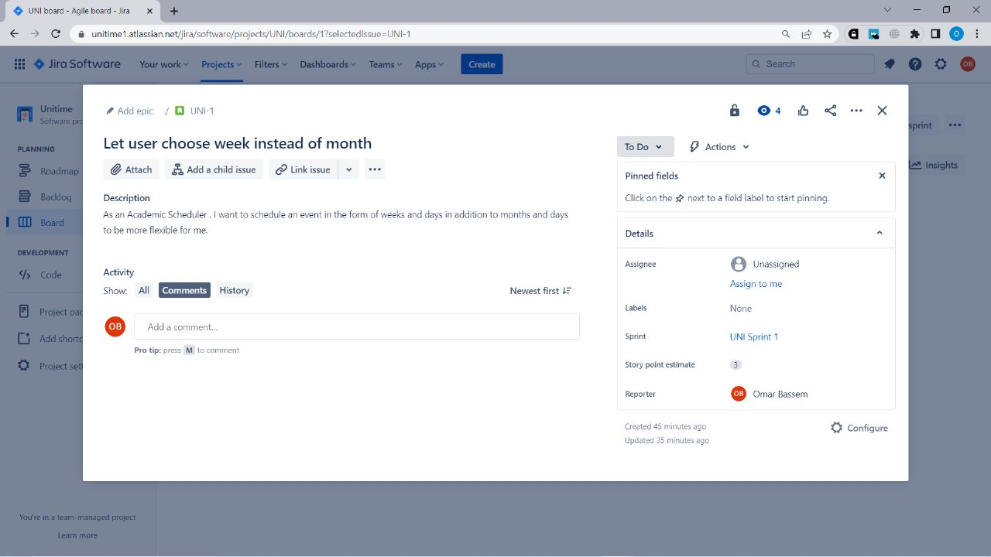

Jira Link: <https://unitime1.atlassian.net/jira/software/projects/UNI/boards/1?selectedIssue=UNI-1>